教学目标：
1语言目标：掌握本单元词汇，听懂、掌握谈论中外不同国家文化的语言材料。
2 技能目标：能听懂语言材料，掌握听的技巧；能读懂介绍中外不同文化的文章。
3 情感目标：通过开展角色表演等活动，培养学生阅读兴趣。通过本单元的阅读，培养学生的文化意识，陶冶思想情操。
教学重点：
(1) 短语:
Section A 1
the Water Festival, the Dragon Boat Festival, Spring Festival, the Lantern Festival, watch the races, a little crowded, like best, go…for one’s vacation, enjoy doing sth., eat out, five meals a day, put on, in two weeks, sound like, from…to…, be similar to, throw water at each other, wash away, have good luck, in the new year
Section A 2
celebrate Middle-Autumn Festival, the shape of, carry …to…, shoot down, plan to do sth., try to do sth., refuse to do sth., fly up, so…that…,call out, lay out, start the tradition of
Section A 3
one…, the other…, give…to…,take out, more and more popular
Section B 1
dress up, care about, make money, used to, end up, warn sb. to do sth., expect sb. to do sth., wake up, find out, decide to do sth., promise to do sth., in need,
Section B 2
introduce sb., make sb. do sth., give birth to life, not only…but also…
(2) 句子:
Section A 1
Bill thinks that the races were not that interesting to watch.
Bill wonders whether they’ll have the sweet rice dumplings again next year.
What do you like best about the Dragon Boat Festival?
What did you do on your vacation?
But I believe that April is the hottest month of the year there.
I wonder if it’s similar to the water festival of Dai people in Yunnan Province.
Section A 2
Chinese people have been celebrating Middle-Autumn Festival and enjoying mooncakes for centuries.
They carry people’s wishes to the families they love and miss.
However, most people think that the story of Chang’e is the most touching.
Whoever drank this could live forever.
Hou Yi was so sad that he called out her name to the moon every night.
How he wished that Chang’e could come back!
Section A 3
Do you know that there are two special days for parents in America?
I believe that there are many ways to show our love.
It is also a good idea to help parents to do something instead.
Section B 1
Many would agree that when we think of Christmas, we probably think of gifts, Christmas trees and Santa Claus.
A Christmas Carol is a famous novel written by Charles Dickens.
He just cares about whether he can make more money.
Marley used to be just like Scrooge, so he was punished after he died.
He now treats everyone with kindness and warmth, spreading love and joy everywhere he goes.
Section B 2
Not only do people spread them around in different hiding places for an egg hunt, but they also give out these treats as gifts.
教学难点：
1. 学会运用宾语从句来表达句子。
2. 学会运用what和how表达对某事物的感叹。

Step 1 Presentation
Show some pictures and words related to Halloween.
Let students say something about Halloween.
Step 2 Listening
1. Finish 1a: Look at the pictures and words related to Halloween. What do you
think this festival is about?
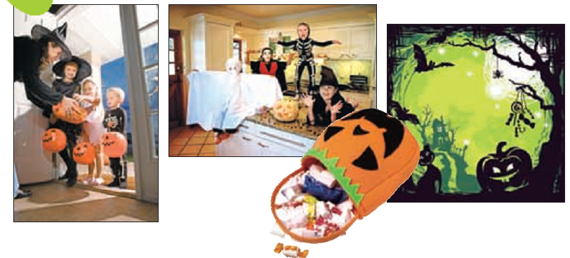
scary dress up haunted house black cat
candy ghost trick or treat October spider
Learn the new words: haunted, ghost, trick, treat, spider
2. Finish 1b: Listen and answer the questions.
1) Where is Halloween popular?
It’s in North America.
2) When do people celebrate Halloween?
People celebrate Halloween in October 31th.
3) What does Wu Yu think of this festival?
Scary and fun.
3. Finish 1c: Listen again and fill in the blanks.
1) Many people make their ______ look scary. They may _______ the lights and light candles. They sometimes also put things like spiders and ghosts around the doors and ________.
2) Little kids and even parents ________ as ghosts or black cats. They can also dress up as fun things like _______ characters.
3) Parents take their children around the neighborhood to ask for _______ and treats.
4) “Trick or treat” means kids will ______ a trick on you if you don’t ____ them a treat.
Answers: houses, turn off, windows, dress up, cartoon, candies, play, give
Step 3 Pairwork
1d Think about the Halloween activities that interest you most. Discuss what you have learned with a partner.
Step 4 Reading
1. Warming up: give students some pictures about Christmas and finish 2a .
2. Reading tasks:
1) Introduce Charles Dickens.
2) Finish 2b: Read the passage about Christmas and answer the questions.
a. What are the common things that people think of for Christmas?
b. Who wrote A Christmas Carol?
c. What is the true meaning or spirit of Christmas?
3) Finish2c: Read the passage again and complete the chart.
the Ghost of Christmas Past?
the Ghost of Christmas Present?
the Ghost of Christmas Yet
to come?
Learn some new words: present, dead
4) Finish 2d: Answer the questions. Some answers need to be inferred.
a. Why does Scrooge hate Christmas?
He is mean and only thinks about himself. He doesn’t treat others nicely. He just cares about whether he can make more money.
b. Does Scrooge have a lot of friends? Why or why not?
No, he doesn’t. He is mean and only thinks about himself.
c. Why was Jacob Marley punished after he died?
He is mean and only thinks about himself, and doesn’t treat others nicely.
d. Does Jacob Marley want to help Scrooge? How do you know?
Yes, he does. He warns Scrooge to change his ways if he doesn’t want to end up like him. He also tells Scrooge to expect three spirits to visit him.
e. How does Scrooge feel when he wakes up on Christmas Day?
He feels scared.
f. What does Scrooge do after seeing three spirits?
He decides to change his life and promises to be a better person. He happily celebrates Christmas with his relatives. He also gives gifts to people in need. He now treats everyone with kindness and warmth, spreading love and joy everywhere he goes.
Learn some new words: punish, warmth
Step 5 Language points
1. But behind all these things lies the true meaning of Christmas…
lie v. (lay, lain) 存在; 平躺; 处于
注意与lay的区别：
lay v. (laid, laid)下蛋; 产卵
【运用】用lie或lay的适当形式填空。
1) ________ in bed all the time is bad for your health.
2) The hen _____ an egg every day.
3) My mother ____ on the sofa for about an hour this morning.
4) The duck _____ three eggs last week.
Keys: Lying, lays, lay, laid
2. He warns Scrooge to change his ways if he doesn’t want to end up like him.
warn v. 警告; 告诫
常用于以下固定短语: warn sb. (not) to do sth. 表示“警告某人(不要)干某事”；warn sb. of/about sth. 表示“提醒 / 警告某人注意某事”。如:
The police warned us not to go out at night.
They warned him of the danger.
She warned her son about the fire.
end up 最终成为; 最后处于
3. The Spirit of Christmas 圣诞精神(圣诞节的意义)
He also tells Scrooge to expect three spirits to visit him.
他还告诉斯克鲁奇准备好等待三个幽灵的造访。
第一个短语中spirit指与肉体相对而言的“精神; 心灵”解; 第二个句子中spirit是“灵魂; 鬼怪; 幽灵”之意。
试比较:
I shall be with you in spirit.
我在精神上也你们同在。
In the story, it is said that the area is haunted by evil spirits.
在故事里, 据说那片地区闹鬼。
4. He is mean and only thinks about himself.
mean在句中作形容词, 意思是“吝啬的; 小气的; 自私的”。如:
Mr. Smith is a mean old man.
史密斯先生是一个小气的老头。
He was mean to those who worked for him.
他对那些为他工作的人刻薄小气。
Some people around us are mean with money.
我们周围有些人在金钱方面十分吝啬。
5. He now treats everyone with kindness and warmth, spreading love and joy everywhere he goes.
他现在用善良和温暖对待任何人, 到处传播爱与快乐。
spread v. (spread, spread) 传播; 展开
n. 蔓延; 传播
Step 6 Summary
dress up, care about, make money, used to, end up, warn sb. to do ath.,
Step 7 Homework
1. Finish 2e on page 15: What do you think the three ghosts say to Scrooge when they visit him? In groups of four, make a conversation between the three ghosts and Scrooge. Role-play the conversation next time.
2. Remember the new words and expressions.

